Print version for In-Person Early Voting or Election Day Leaflet or Yard Sign

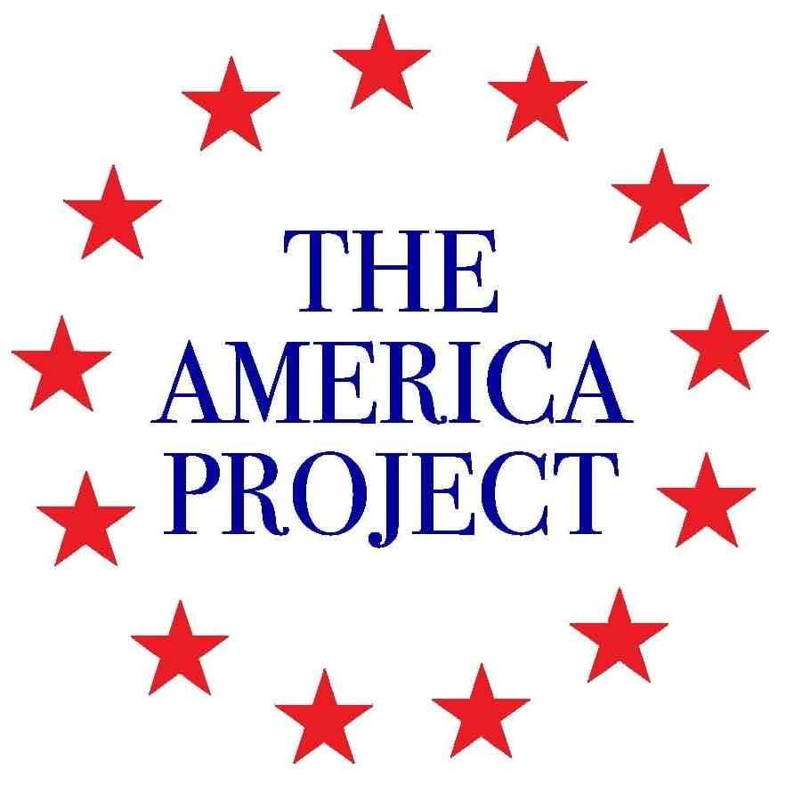

Obs Citizen Election Observer

Help protect election integrity as you vote!

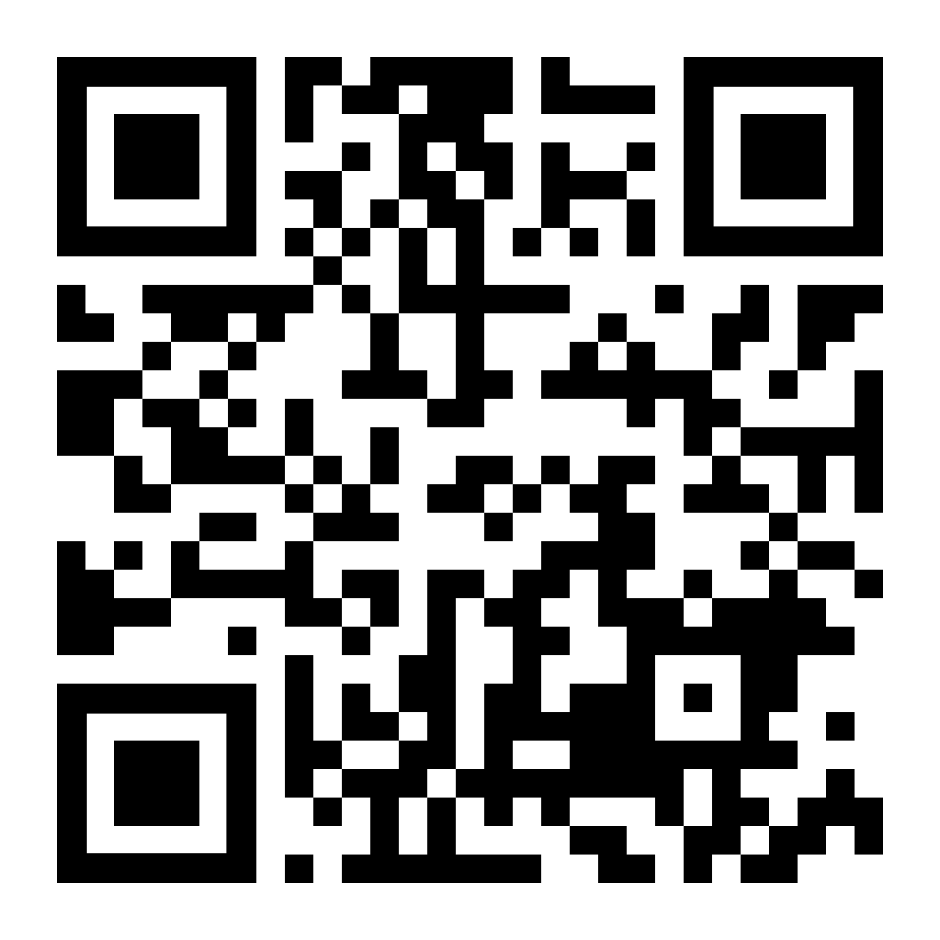
Transparency is the key to deterring fraud and ensuring a free and fair election for all voters. You can help make the election more transparent by observing the process as you cast your ballot. Just click on the QR code, or go to the web address, and fill in a simple form as you vote. Together, we can ensure the election is fair and transparent!

www.electionobserver.us

Electronic Version for Email Circulation or Posting to Websites

Citizen Election Observer

Help protect election integrity!

If you are unable to work as an election official or poll watcher, you can still help protect election integrity by serving as a citizen observer before the election and/or while voting on election day. The process is easy. Simply look around as you go through the voting process, then record responses to a few simple questions, and press send! The Citizen Election Observer Guide allows ordinary citizens to assess and report on the election process as they vote.

The guide includes addition resources like a Citizen Election Observer Badge that you can print out and wear while observing, a checklist that enables citizen observers to Assess the Pre-Election Environment, an Incident Report Form for use if you witness election malpractice or fraud, and an Election Reform Survey. We also have a video Introduction to Citizen Observation. Together, we can ensure the election is fair and transparent!

Deter Fraud While You Vote (highlighted text can be cut for space concerns)
Tim Meisburger

There is a crisis of confidence in American elections, and for good reason. Last minute changes in election procedures in response to the COVID pandemic created massive security flaws in the 2020 elections that have severely weakened public trust in the integrity of the stoked public doubt. According to a recent Rasmussen poll, a majority of Americans now think there was cheating in the 2020 elections, and a huge majority are concerned with election integrity.

While some portray concern with election integrity as solely a Republican issue linked to the disputed 2020 election, the polling cited above demonstrates it is also an important concern for majorities of both Democrats and Independents; and one must only look back to 2018 to see prominent Democrats (including the current Vice President) expressing concerns about election integrity.

The truth is that election integrity must matter to all Americans, for without elections that are transparent and credible, and that accurately reflect the will of the people, we lose our republic. We are a self-governing people, and with our rights and liberties comes the responsibility to protect and defend our republic for ourselves, our fellow citizens, and our posterity.

I spent many years overseas working on democracy and election programs, and there learned that the only effective way to increase public trust in elections is to increase transparency so that voters can independently assess and validate the process. This requires both legal and procedural reform, and increased access for poll watchers and election observers.

Working as an election official or as a party poll watcher requires extensive training and a significant time commitment. Unfortunately, many people who are interested in promoting election integrity do not have the time to work as a poll watcher or worker. To enable these people to participate in election observation, and help protect election integrity, we have developed an innovative new program called Citizen Election Observer (CEO).

The program provides observation tools that voters can access through their cell phones before the election, or while they are at a polling station to cast their ballot. The process is easy. Simply open the web page, click on the process you want to report on, record responses to a few simple questions, and press send! The visible presence of citizen observers can help deter cheating, and the data collected from the observers will be used to assess the quality of the election and to make recommendations for reform.

The CEO tools can be accessed through the Citizen Election Observer Guide (www.electionobserver.us). Included in the guide is a checklist for observing in-person or election day voting, which you can fill out and submit as you go through the voting process. Since many things can occur before the election that affect the integrity and legitimacy of the process, a simple checklist to help assess the pre-election environment is also included, which can be filled in at any time before or after voting.

Although not required for observation, voters can download and print a conference badge that identifies them as Citizen Election Observers as they go through the voting process. Wearing the badge lets officials and party representatives know they are under increased scrutiny and may help deter malpractice. Occasionally voters may witness administrative irregularities or even fraud, and to help ensure they know what information to collect to facilitate follow-up, an Incident Report Form is also included.

Transparency is the key to deterring election fraud and malpractice. By participating in the CEO program, ordinary voters can promote election integrity, helping to ensure free and fair elections for all Americans, regardless of their political party.

Tim Meisburger worked 30 years on international democracy and elections programs, was Director of the Center for Democracy Rights and Governance in the Trump Administration, and is currently Director of Election Integrity at the America Project

